Mini Homework 1

* ‬

Running EC2 Instance

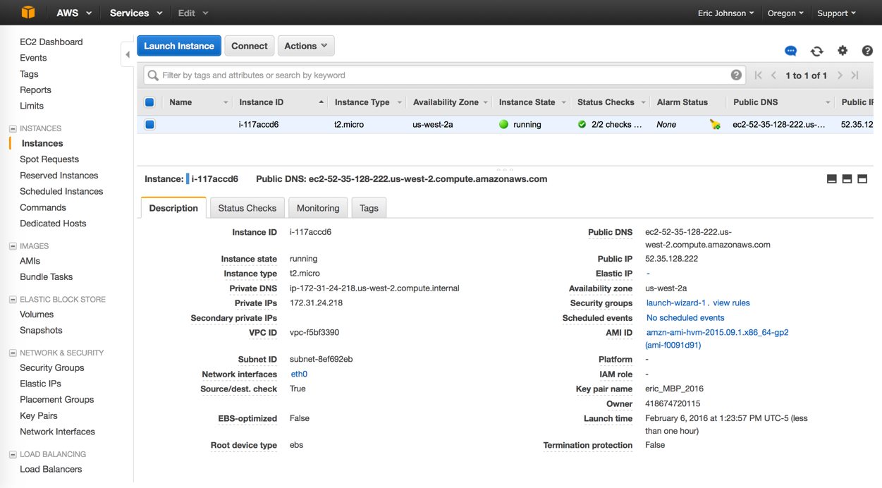

Running S3 Bucket

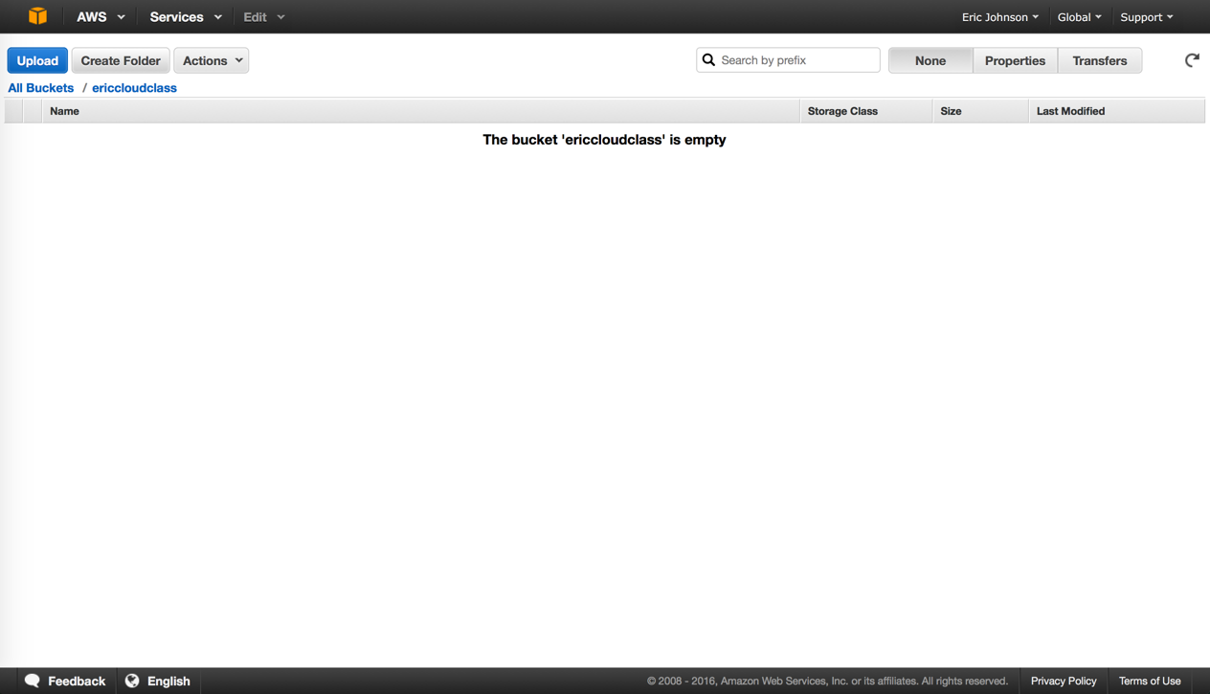

‬

SSH Session (OS X) into EC2 Instance

